**NAME RAJDEEP JAISWAL UID – 20BCS2761**

**BRANCH – B.TECH (CSE) SEC/GROUP – 26(B)**

**SEMESTER – 2ND D.O.P – 3 MAY 2021**

**SUBJECT – COMPUTER WORKSHOP**

**TOPIC - How to make a bootable stick on windows and ubantu?**

1. Overview

With a bootable Ubuntu USB stick, you can:

* Install or upgrade Ubuntu
* Test out the Ubuntu desktop experience without touching your PC configuration
* Boot into Ubuntu on a borrowed machine or from an internet cafe
* Use tools installed by default on the USB stick to repair or fix a broken configuration

Creating a bootable Ubuntu USB stick from Microsoft Windows is very simple and we’re going to cover the process in the next few steps.

2. Requirements

You will need:

* A 4GB or larger USB stick/flash drive
* Microsoft Windows XP or later
* [Rufus](https://rufus.ie/), a free and open source USB stick writing tool
* An Ubuntu ISO file. See [Get Ubuntu](https://www.ubuntu.com/download) for download links

3. USB selection

Perform the following to configure your USB device in Rufus:

1. Launch Rufus
2. Insert your USB stick
3. Rufus will update to set the device within the Device field
4. If the Device selected is incorrect (perhaps you have multiple USB storage devices), select the correct one from the device field’s drop-down menu

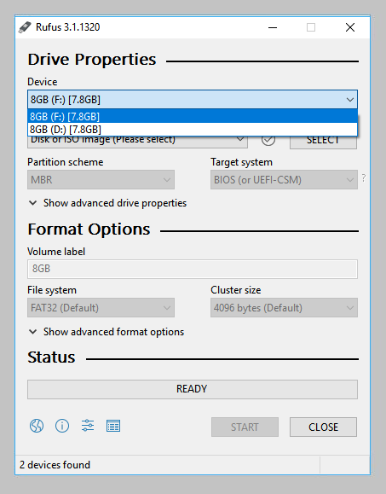

## 4. Boot selection and Partition scheme

Now choose the Boot selection. Choices will be Non bootable and FreeDOS. Since you are creating a bootable Ubuntu device select **FreeDOS**.

The default selections for Partition scheme (MBR) and Target system (BIOS (or UEFI-CSM)) are appropriate (and are the only options available).

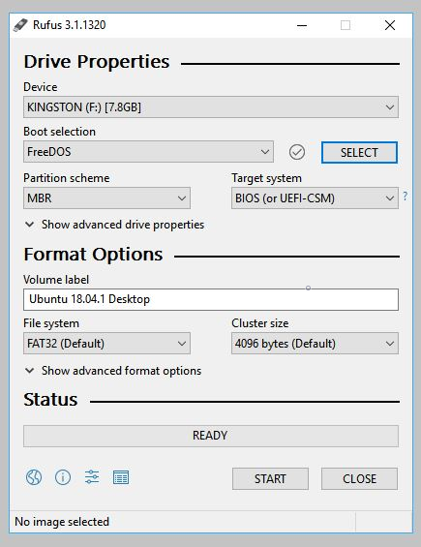

## 5. Select the Ubuntu ISO file

To select the Ubuntu ISO file you downloaded previously, click the **SELECT** to the right of “Boot selection”. If this is the only ISO file present in the Downloads folder you will only see one file listed.

Select the appropriate ISO file and click on **Open**.

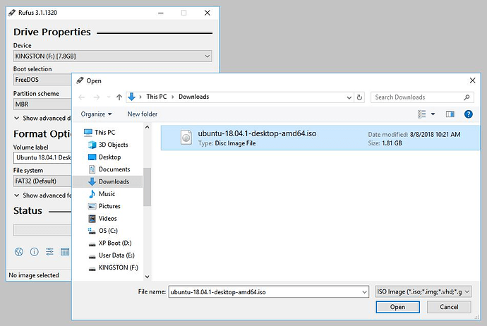

## 6. Write the ISO

The Volume label will be updated to reflect the ISO selected.

Leave all other parameters with their default values and click **START** to initiate the write process.

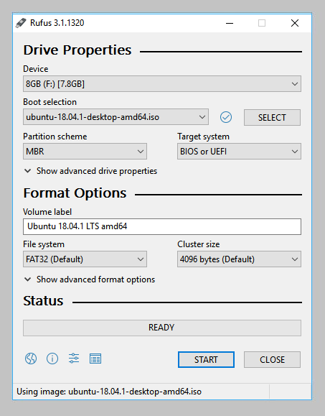

## 7. Additional downloads

You may be alerted that Rufus requires additional files to complete writing the ISO. If this dialog box appears, select **Yes** to continue

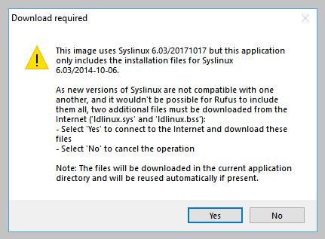

## 8. Write warnings

You will then be alerted that Rufus has detected that the Ubuntu ISO is an ISOHybrid image. This means the same image file can be used as the source for both a DVD and a USB stick without requiring conversion.

Keep Write in ISO Image mode selected and click on **OK** to continue.

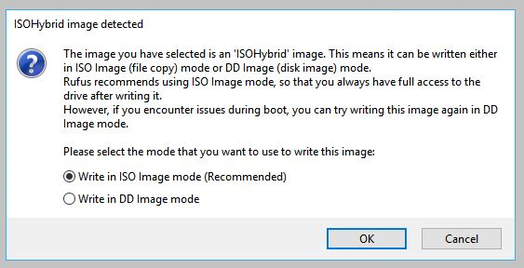

Rufus will also warn you that all data on your selected USB device is about to be destroyed. This is a good moment to double check you’ve selected the correct device before clicking OK when you’re confident you have.

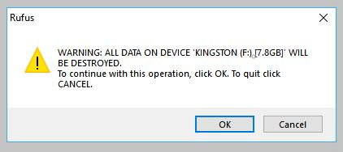

## 9. Writing the ISO

The ISO will now be written to your USB stick, and the progress bar in Rufus will give you some indication of where you are in the process. With a reasonably modern machine, this should take around 10 minutes. Total elapsed time is shown in the lower right corner of the Rufus window.

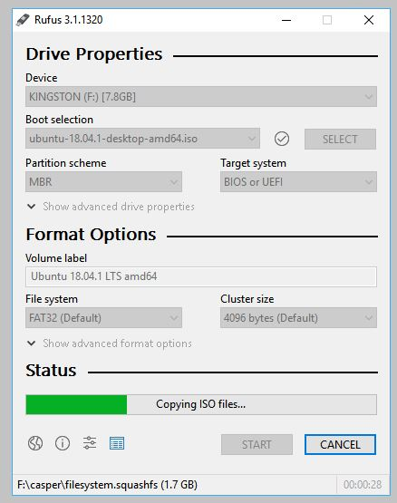

## 10. Installation complete

When Rufus has finished writing the USB device, the Status bar will be green filled and the word **READY** will appear in the center. Select **CLOSE** to complete the write process.

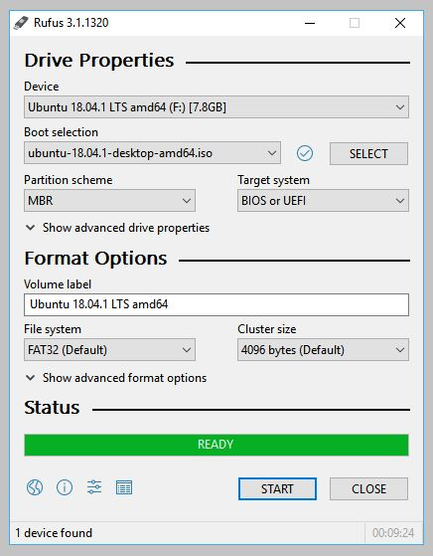

LEARNING OUTCOMES

1. Apply coding skills to solve application based problems on competitive platforms such as Hacker Rank/ Hacker Earth/Code Chef.
2. Understand the basic concept and structure of computer hardware
3. Identify the existing configuration of the computers and peripherals.
4. Installing and uninstalling multiple operating systems on a machine.
5. Apply their knowledge about computer peripherals to identify /rectify problems on-board.

EVALUATION COLUMN (To be filled by concerned faculty only)

|  |  |  |  |
| --- | --- | --- | --- |
| **Sr. No.** | **Parameters** | **Maximum**  **Marks** | **Marks**  **Obtained** |
| 1. | Worksheet Completion including writing learning objective/ Outcome | 10 |  |
| 2. | Post Lab Quiz Result | 5 |  |
| 3. | Student engagement in Simulation/ Performance/ Pre Lab Questions | 5 |  |
| 4. | Total Marks | 20 |  |